Chapter 8, Problem 46.

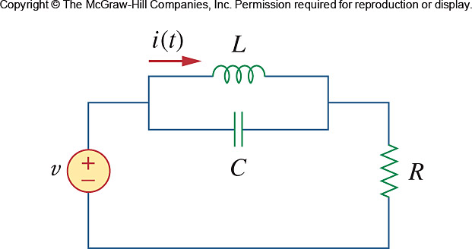
Using Fig. 8.93, design a problem to help other students better understand the step response of a parallel RLC circuit.

Figure 8.93
For Prob. 8.46.

